- Recipients will receive an email similar to below:

From: on behalf of [email sender] do-not-reply@proofpointessentials.com

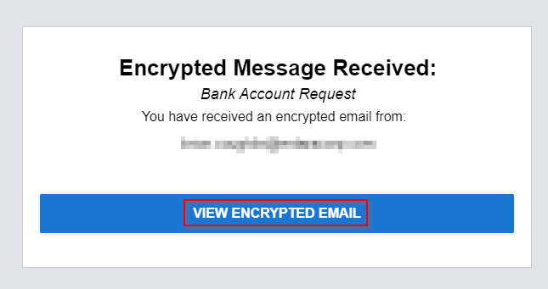

- Do view the email recipient must click “VIEW ENCRYPTED EMAIL” boxed in above shot

- Recipients will be directed to a Proofpoint login screen where they will need to enter their email address & click Continue

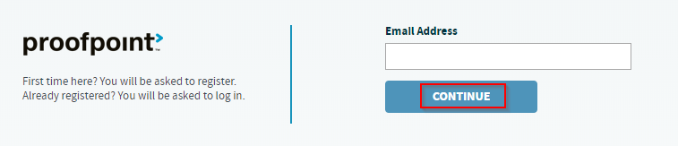

- If the recipient has done this process before they will enter their Proofpoint account password, click Sign in, & will then be logged into their Proofpoint account with access to encrypted emails. If they are going through this for the first time proceed to the next step.

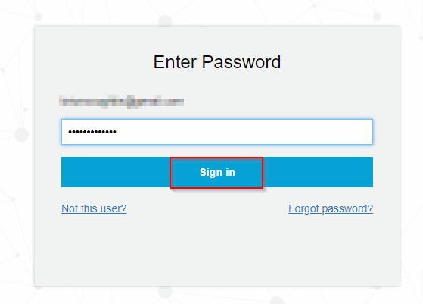

- First time recipients will need to fill out below form, click I agree checkbox, & click Register

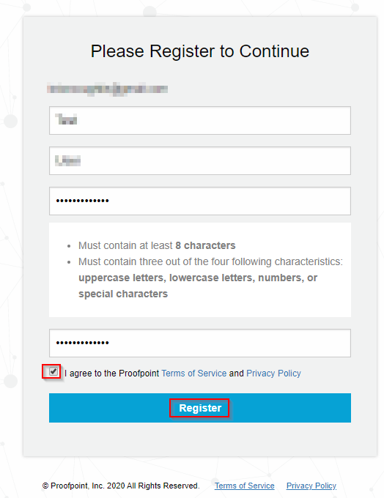

- Recipient will then receive below email and will need to click “CONFIRM”

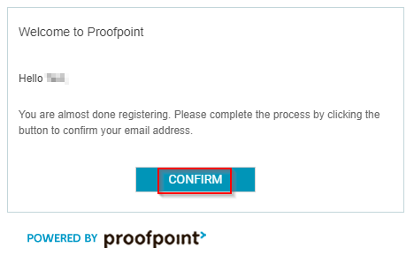

- Recipient will then be directed to the below page with a registration successful prompt. Click Continue logging in.

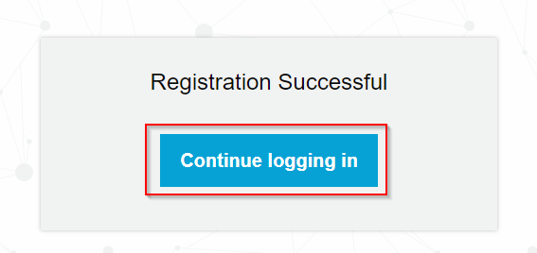

- Recipient will then login with their email & new Proofpoint password

- Recipient is now logged into Proofpoint where they have access to any encrypted emails you have sent them. Note the emails will automatically delete after 15 days.

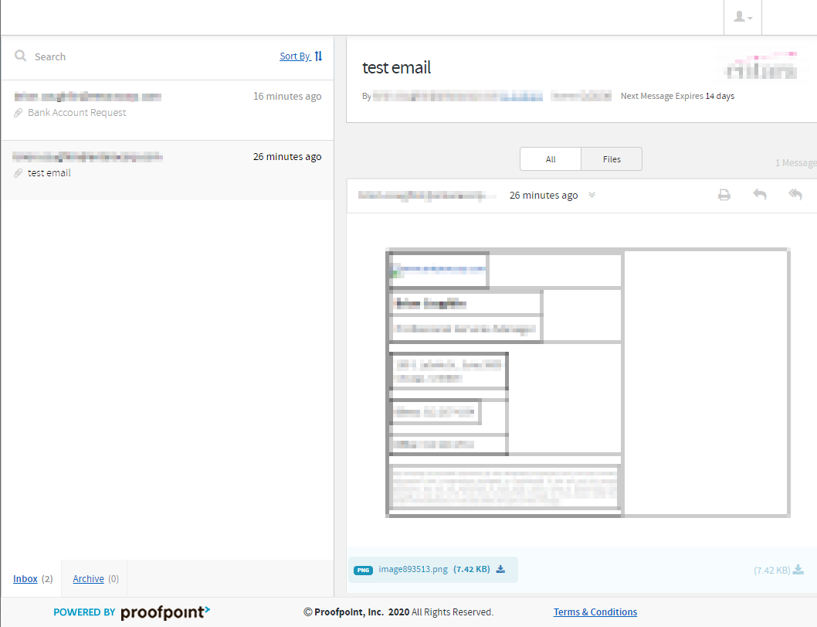

- Recipients do have the ability to reply to the email in their Proofpoint portal, which will be encrypted as well

